**How-to Guide for the Learning Express Library at Sheppard Memorial Library**

**for access to FREE ACT, SAT, AP Exam and PSAT study guides & practice tests**



**Step 2:**

**Click on Student Resources**

**Step 1:**

**Log onto Sheppard Memorial Library’s website at**

<http://sheppardlibrary.org/home>

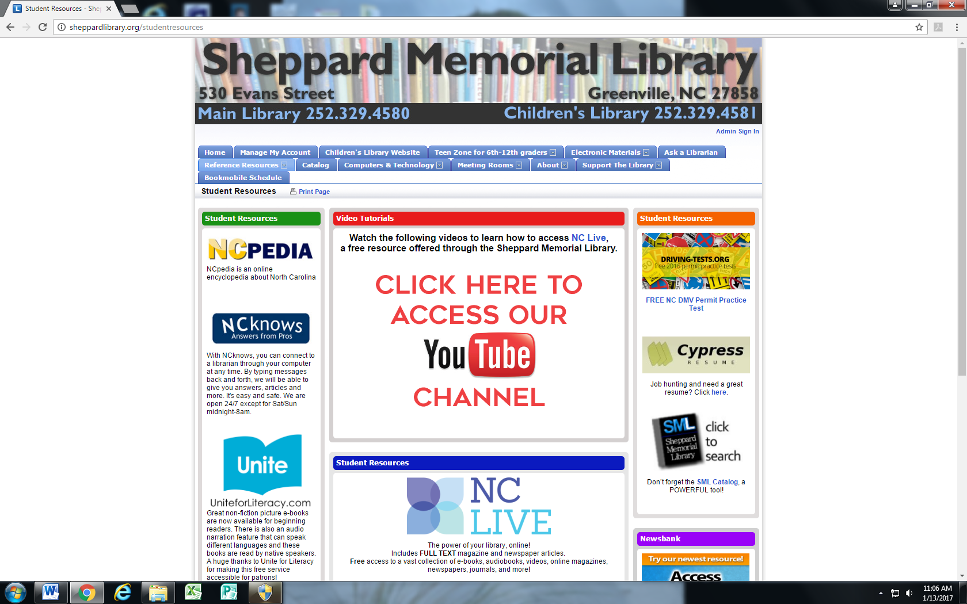

**Step 3:**

**Scroll towards the bottom of the page…**



**Step 4: Click here!**

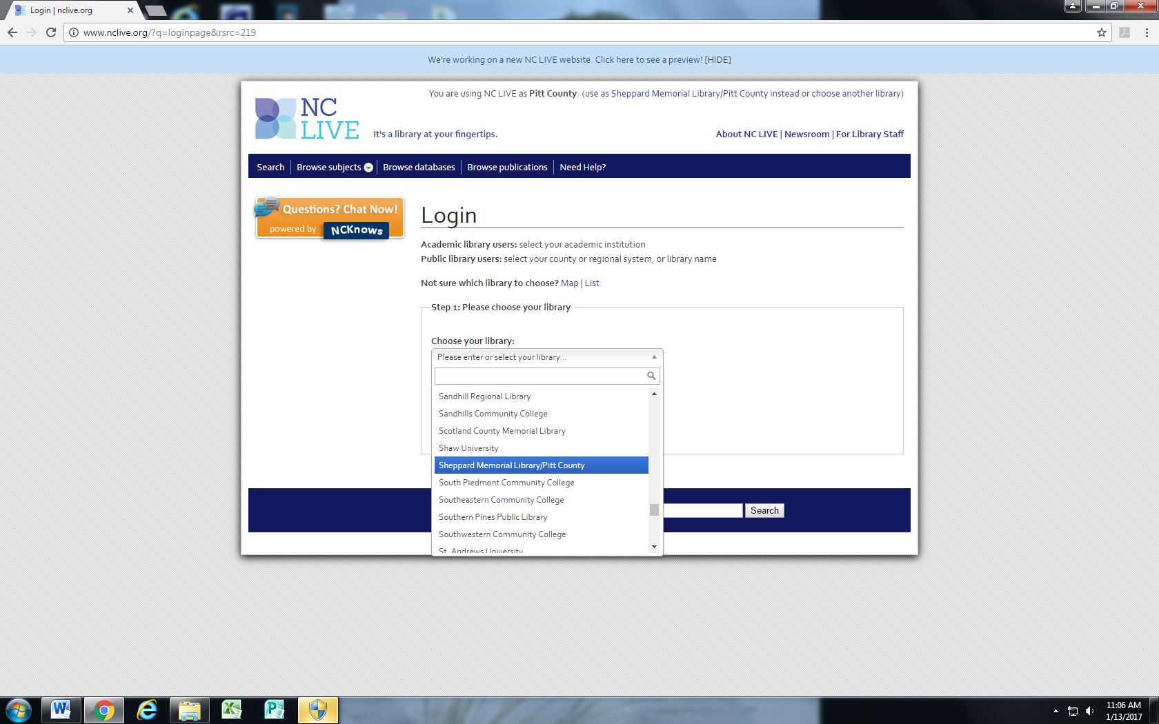

**Step 5: Select   
Sheppard Memorial/Pitt County**

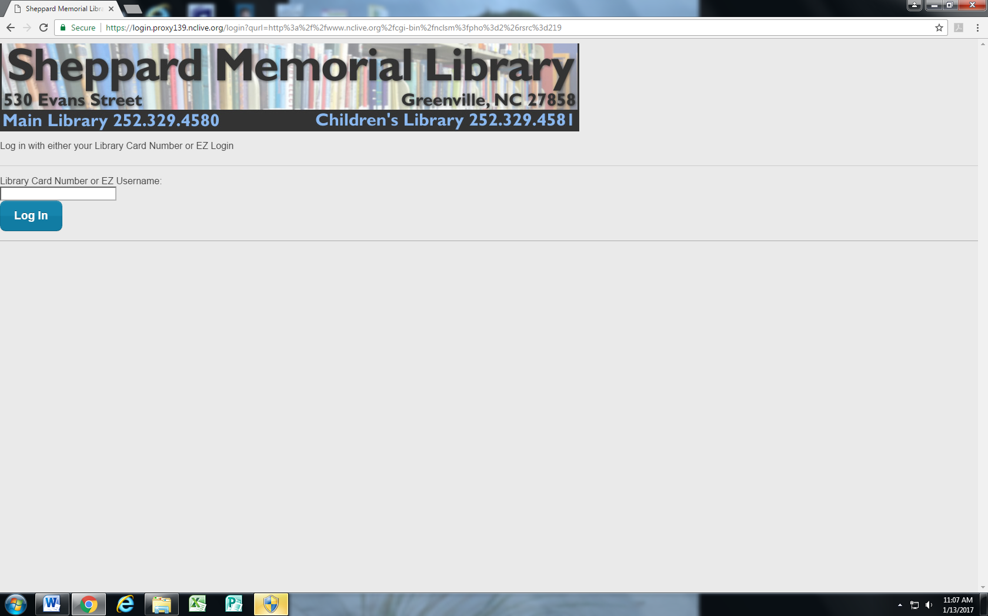

**Step 6: Enter your library card number**

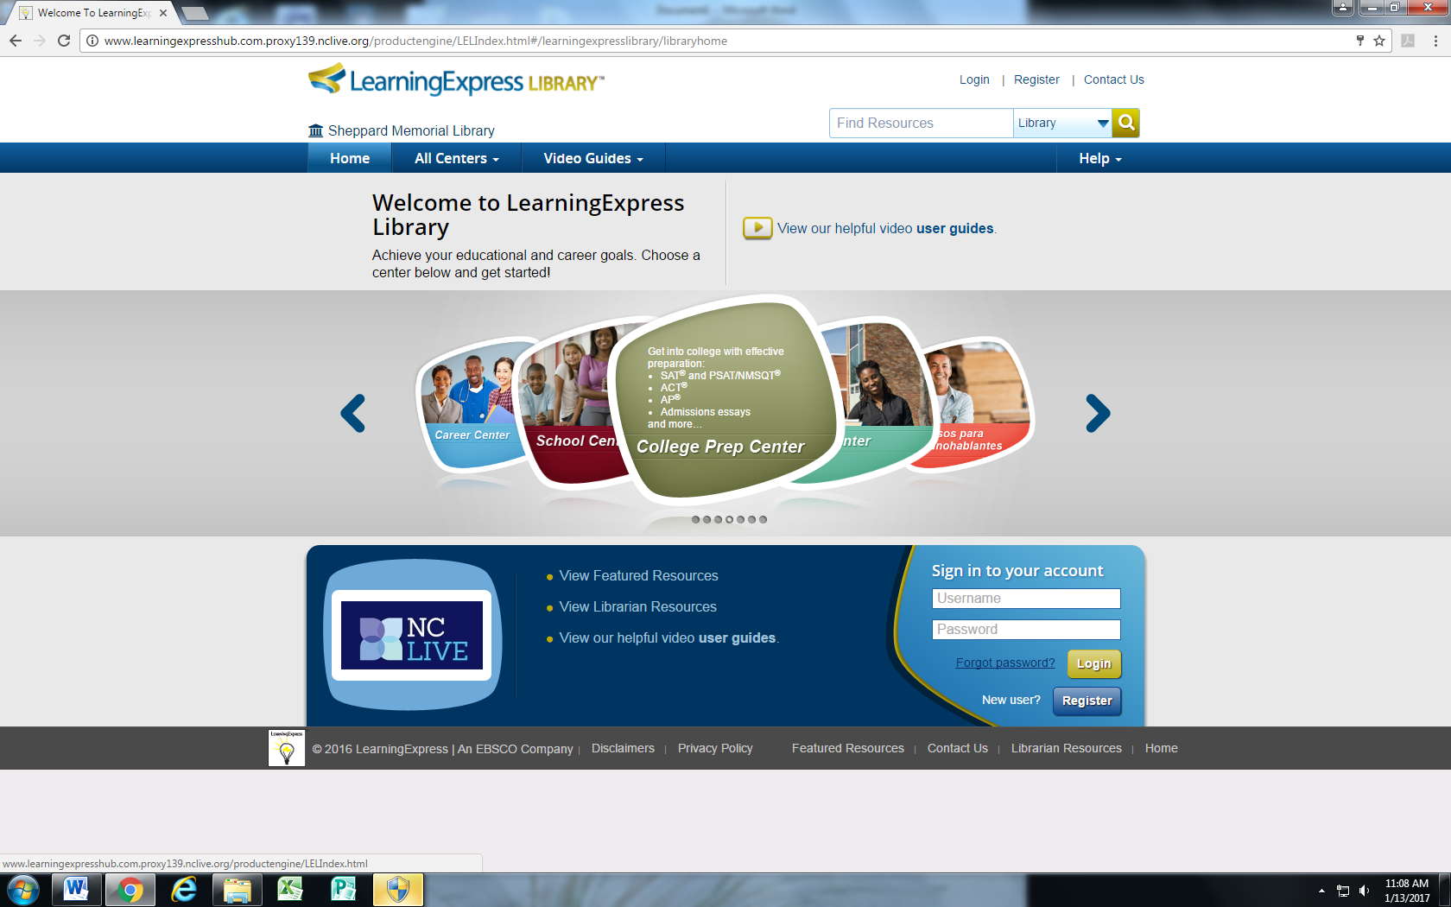

**Step 7: First time users will need to “register”. Returning users can enter their account log in information.**

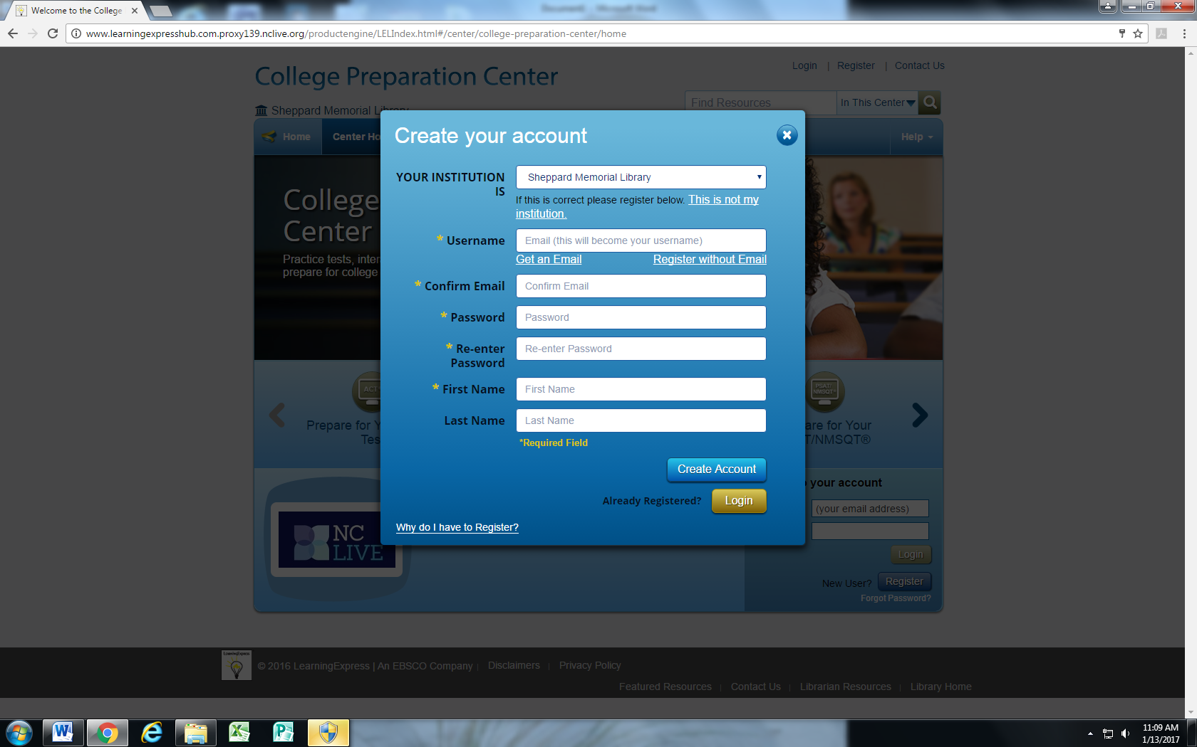

**It’s free to register!**

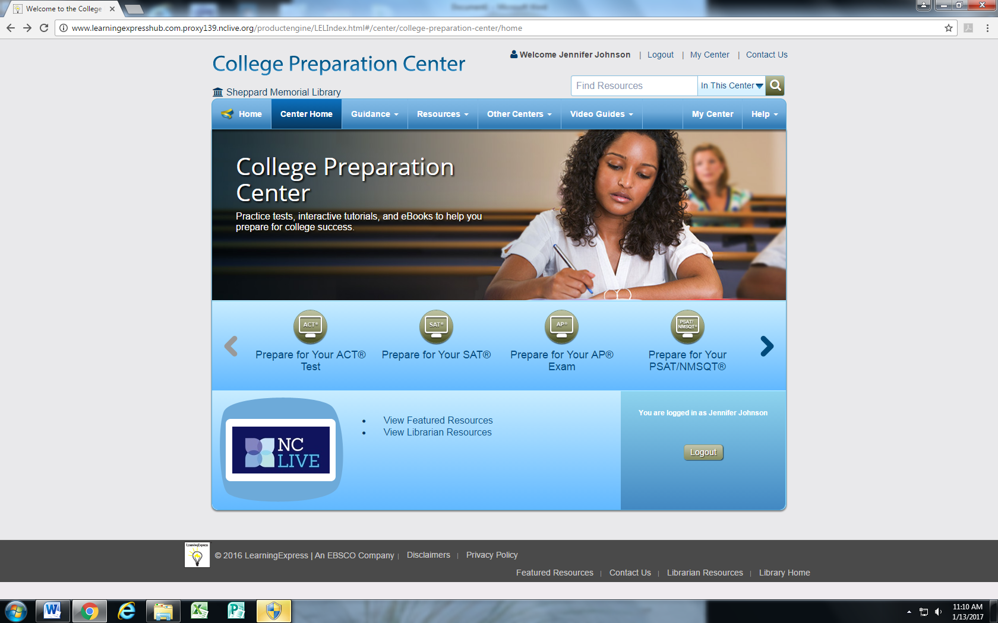

**Step 8: Choose the topic area you are interested in**

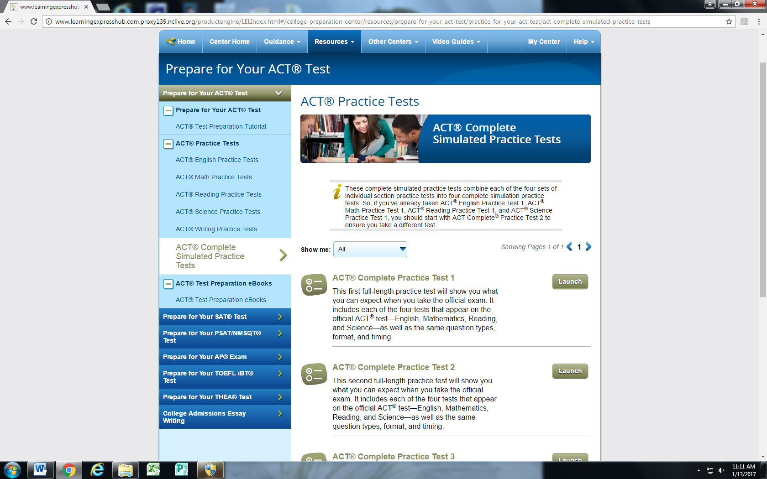

**Step 9: Use navigation menus to explore the resources available to you**

